What is a Gantt Chart?

A Gantt chart is a type of bar chart used to plan, schedule, and track the progress of a project over time. It displays a list of tasks or activities on one side (usually the vertical axis) and a timeline across the top (horizontal axis), which can be divided into days, weeks, or months depending on the project.
Each task is represented by a horizontal bar. The position and length of the bar show when the task starts, how long it will take, and when it is expected to finish. This visual layout makes it easy to understand the sequence of tasks, identify which activities overlap, and see how different parts of the project are connected.
A Gantt chart also helps project managers and team members monitor progress. By updating the chart, they can quickly see which tasks have started, which are currently in progress, and which have been completed. For example, a simple legend might use colors such as 🟩 for Start, 🟨 for In Progress, and 🟥 for End.

Use Case Diagram
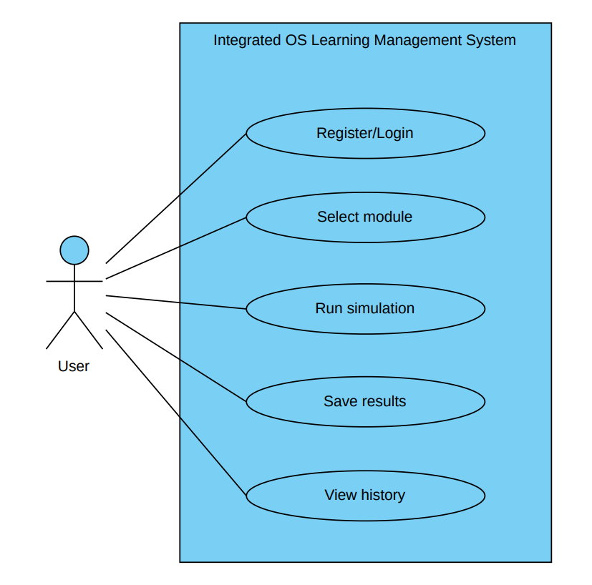

The Use Case Diagram for the Integrated OS Learning Management System. The system involves one primary actor, which is the User. The user interacts with the system by performing several key functions. First, the user can register and log in to access the system. After successful authentication, the user is able to select a module, which may include CPU Scheduling, Memory Management, or Deadlock simulations. Once a module is selected, the user can run simulations by providing the required input data. The system then processes the input and displays the results. The user has the option to save the simulation results for future reference. Additionally, the user can view history to access previously saved simulations and track their progress.

ERD - Entity Relationship Diagram

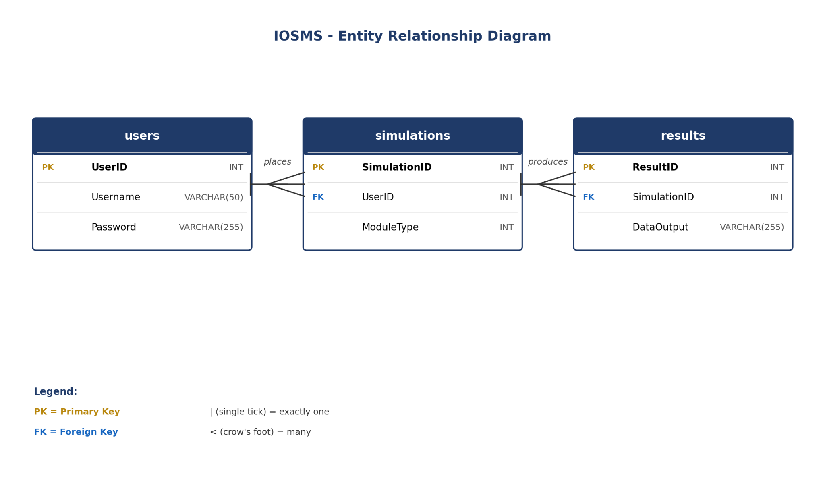

The Entity Relationship Diagram for the Integrated OS Learning Management System. The database consists of three main entities: users, simulations, and results. The users entity stores account information, including a unique UserID, Username, and a securely hashed Password. The simulations entity records every simulation run by a user, identified by a SimulationID and linked to its owner through a UserID foreign key, along with a ModuleType field that indicates which OS module the simulation belongs to (CPU Scheduling, Memory Management, or Deadlock). The results entity holds the output data of each simulation, identified by a ResultID and connected to its parent simulation through a SimulationID foreign key, with a DataOutput field that stores the algorithm's textual output. The relationships between the entities follow a one-to-many pattern: one user can place many simulations, and one simulation can produce many results, allowing the system to maintain a complete history of every user's activity and outputs.

